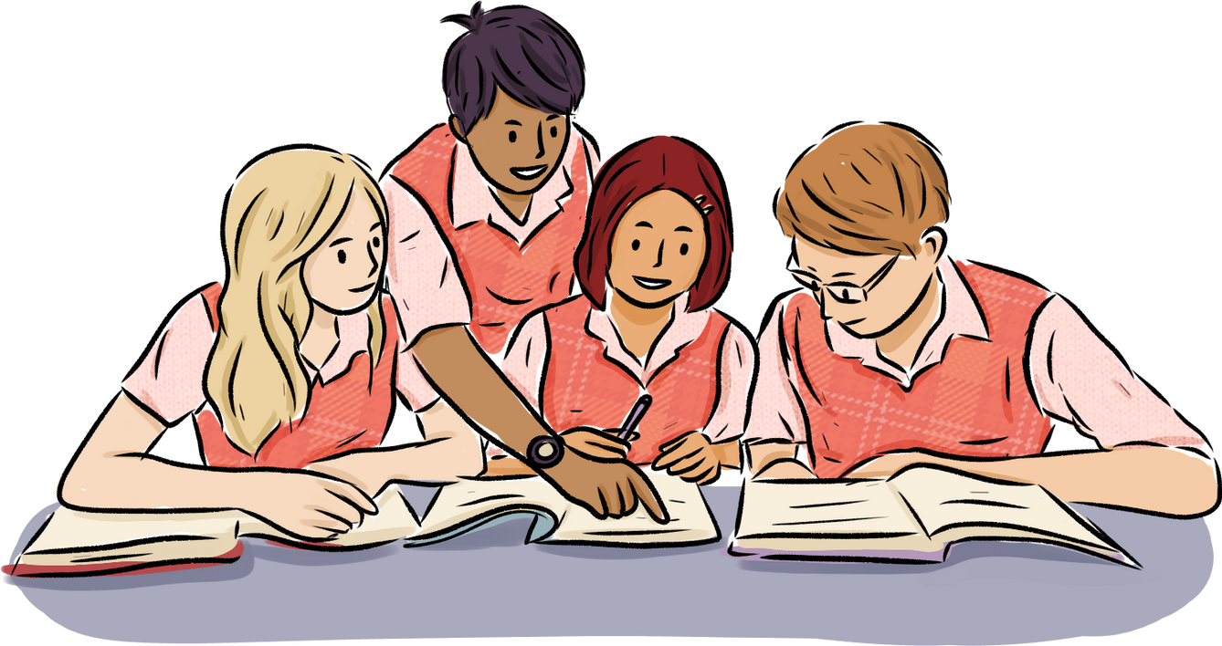
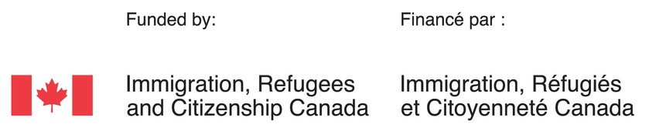
TRANSIT POLICY

The Vietnamese Community Center of Mississauga provides free bus tickets to eligible students at our English classes. Students will receive one ticket in exchange for one transfer each day that they attend the program.

Who is eligible?
Students with medical issues or a valid doctor's note.
Students who live further than 3km from our center.

Requirements
Students are required to fill out and sign a Bus Ticket application and acknowledge the school's policy.
Students must attend school regularly and on time to receive tickets. If a student is absent for more than 5 days in a month without a doctor's note, assistance will cease until attendance improves.

Exceptions During Winter
Seniors and parents (with children who registered in CNC at our organization) who do not meet all eligibility requirements may receive transit assistance during winter months.

FREE ENGLISH CLASSES FOR IMMIGRANTS LEVELS 1 TO 7

Welcome to our Program!
As a multi-cultural non-profit organization, we provide free English classes to newcomers and assist in integrating newcomers to Canadian life and society. In addition, we provide bus tickets to students who are not within walking distance (3km+) of our center. Child- minding services are also available at no costs for parents/guardians who attend our English classes and have children from 19 months to 4 years of age.

Vietnamese Community Center of Mississauga

LANGUAGE AND SKILLS TRAINING PROGRAM

Newcomers of all cultures are welcome

PLEASE VISIT OUR CENTER!
600 Lakeshore Road East Mississauga ON L5G 1J4

Hours of Operation: Monday-Friday 8:30 AM - 4:00 PM

TEL: (905) 891-3825
EMAIL: vccm2021mississauga@gmail.com
WEBSITE: www.cdvnmississauga.org

ATTENDANCE ROUTINE
- Attend class everyday from: 9:00 AM to 12:00 PM or 12:30 PM to 3:30 PM.

- If you will be absent or late, please call the school at (905) 891-3825 to let us know. If you are sick, then a doctor's note will be required upon your return to school.

- If you reach the answering machine, please kindly leave your name, reason for absence or lateness, and the expected date of return.

STUDENT RESPONSIBILITES
- Arrive on time.
- Speak English in class.
- Be prepared for class everyday.
- Engage/participate in class.
- Demonstrate respect & courtesy to all.
- Develop & practice academic honesty and integrity.
- Do not use or display discriminatory or threatening language/behaviour.
- Take care of your child/children at lunch breaks and do not leave the premises without your child/children.
- Follow all safety procedures.
- Help maintain a clean & safe environment.
- Do not smoke on school property.

LANGUAGE AND SKILLS TRAINING
SCHOOL HOURS
MORNING CLASSES
9:00 AM Classes Begin 10:30 AM Break Time 10:50 AM Classes Resume 12:00 PM Dismissal
AFTERNOON CLASSES
12:30 PM Classes Begin 2:00 PM Break Time 2:20 PM Classes Resume
3:30 PM Dismissal

